**JavaScript vs Node.js: Type**

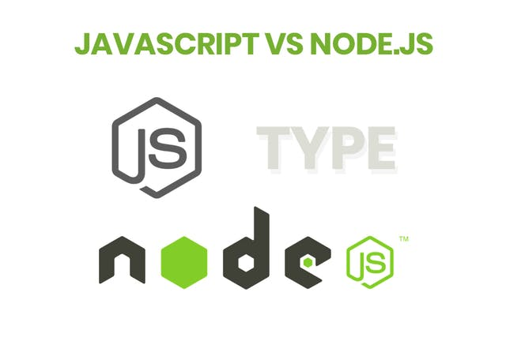

Javascript is a popular programming language and it runs in any web browser with a good web browser.

On the other hand, Node.js is an interpreter and environment for the JavaScript with some specific useful libraries which JS programming can be used separately.

## JavaScript vs Node.js: Utility

Javascript is mainly used for any client side activity for the web application, for example refreshing the page in a specific interval, possible attribute validation or provide any dynamic changes in web app pages without refreshing that particular web page.

It is commonly used by some of the best IT companies providing [software solutions](https://www.xicom.biz/offerings/software-development/?ref=hackernoon.com)for performing or accessing any non-blocking operation of operating system, like executing or creating a shell script or accessing the hardware specific information or running any job in the backend.

## JavaScript vs Node.js: Running Engine

JavaScript running any engine like JavaScript Core (Safari), Spider monkey (FireFox), V8 (Google Chrome)

Node.js only runs in a V8 engine that is mainly used by Google Chrome. And, JS program which will be written with the help of Node.js library will always run in the V8 Engine.

1. JavaScript is mainly used for the client-side activity for one particular web application. Some of these activities can be dynamic page display in some schedule time interval, addressing business validation or basic Ajax call kind of task.

These are used most of the time for any web apps. On the other hand, Node.js is mainly used for running or accessing any operating system for the non-blocking operation.

An operation like executing or creating a shell script, or getting any specific information related to the hardware on one call or the installed details of certificate in the system or various defined task which are most of the time non-blocking on an operating system.

2. JavaScript programming is very easy to write (although, it is subjective as some developers find it difficult too) and put the running environment means right browser.

On the other hand, Nodejs only support the V8 engine that is specific to the googles chrome. But whether it support V8 engine, written in the JavaScript code can be able to run in any given environment. Therefore, there is no constraint to it specific to the browser.

3. JavaScript normally follows standard of Java Programming language. There may have different ways of writing source code but at the same time, we can say that it is following the standards of Java Programming language.

On the other hand, Node.js is written in the C++, and provides V8 engine base that helps developers to run the written program of javascript in any browser environment.